HPOG RoundTable: Advanced Find Guidance Document
  - This instructional document shows how to prepare three reports for the HPOG RoundTable data sessions. Please contact PAGESSupport@urban.org if you have questions not answered in this document. The content includes:
- Accessing Advanced Find and finding the three reports needed for the roundtable
- Running each report
- Exporting each report to Excel
- Opening with Excel and “saving as”
Note: for additional information use the following resources:
- The PAGES User Manual. From the PAGES Welcome Page, find “Document Resources” and click on the entry titled “a PAGES User Guide.”
- The PAGES Reporting Webinars. Also in “Document Resources” on the Welcome Page, find “Reporting in PAGES Training Slides.” Or click here for a link to a recording of the webinar: https://attendee.gotowebinar.com/recording/2015708665061126918

Step 1. Log into PAGES and access advanced find.
If you have trouble accessing PAGES, please contact PAGESSupport@urban.org for assistance. Once in PAGES, access Advanced Find by clicking the following link (found at the top-right corner of any page):

Step 2. Change “Look For” to the appropriate category.
A pop-up will appear with Advanced Find. To find each report, you will need to change the “Look For” field to the correct category. Change “Look For” by clicking the dropdown and selecting the appropriate category. The category for each report is listed below.
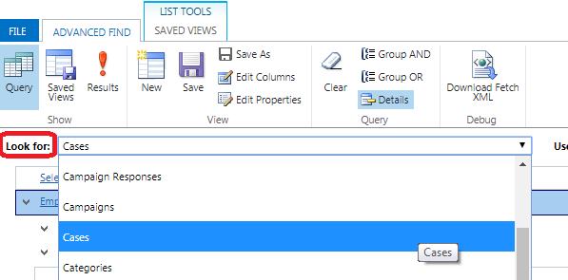

Step 3. Click on “Use Saved View” and find the pre-shared report.
Click on the “Use Saved View” dropdown at top-right of Advanced Find and then scroll down to “My Views” where you will find the RoundTable view:
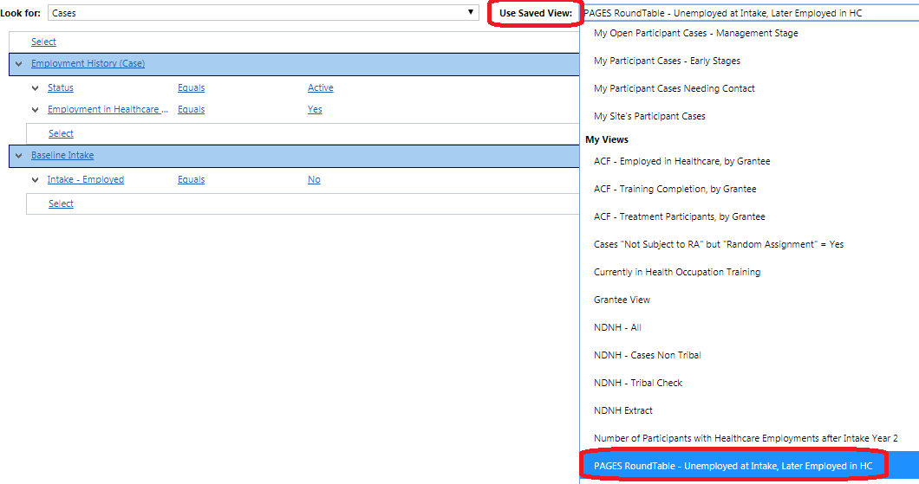

Step 4. Run the report.
Once you have selected a report under “Use Saved View,” click on the “Results” icon to run the report:
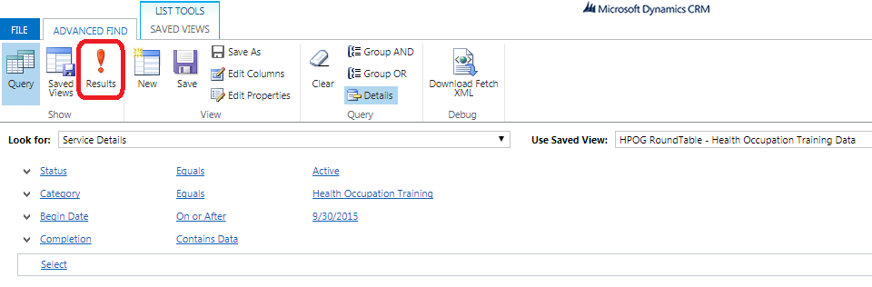

Step 5. Extract the report to Microsoft Excel.
When the results pop up, click on the “Export” tool at the top of the screen (with the Excel icon). It will have the “Look For” category listed (i.e. Export Cases, Export Employment History, Export Service Details, depending on the report you are running). Select “Static Worksheet”:
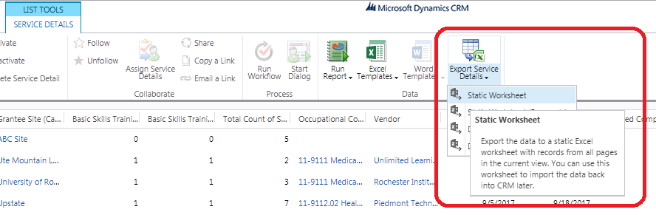

Step 6. Open in Excel.
After clicking “Static Worksheet,” the system will generate an Excel file for download from your browser. This will take approx. 10-20 seconds. It will show up on your browser’s download menu (usually at the bottom or top of the screen). Click “Open.”
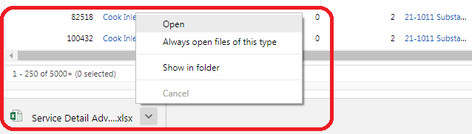

Step 7. “Save As” the report.
An Excel file will open that looks exactly like the report you ran. Click on “Save As” and give the file a new name that you will recognize – for example, “HPOG RoundTable PAGES Report 1 – Cases.” Please ensure that you save these files on the laptop you will be brining or on a USB storage device that you will have access to during the session. You will be working with these files at the RoundTable.
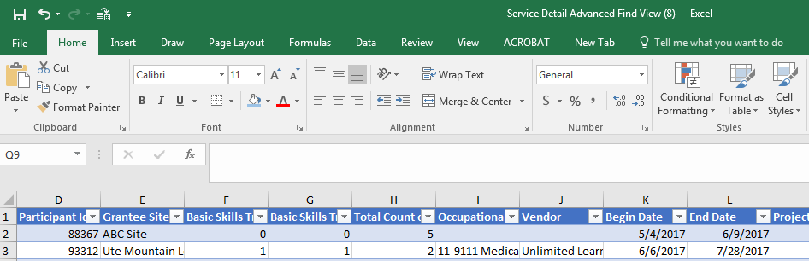

Step 8. Repeat steps 1-7 for all three reports, which can be found by setting “Look For” (Step 2) to the following and finding the reports titles under “My Views”:
Report Number | “Look For” Category | Report Title under “Use Saved View”
1 | Cases | HPOG RoundTable – Unemployed at Intake, Later Employed in HC
2 | Employment History | HPOG RoundTable – Employments in Healthcare
3 | Service Details | HPOG RoundTable – Health Occupation Training Data

